

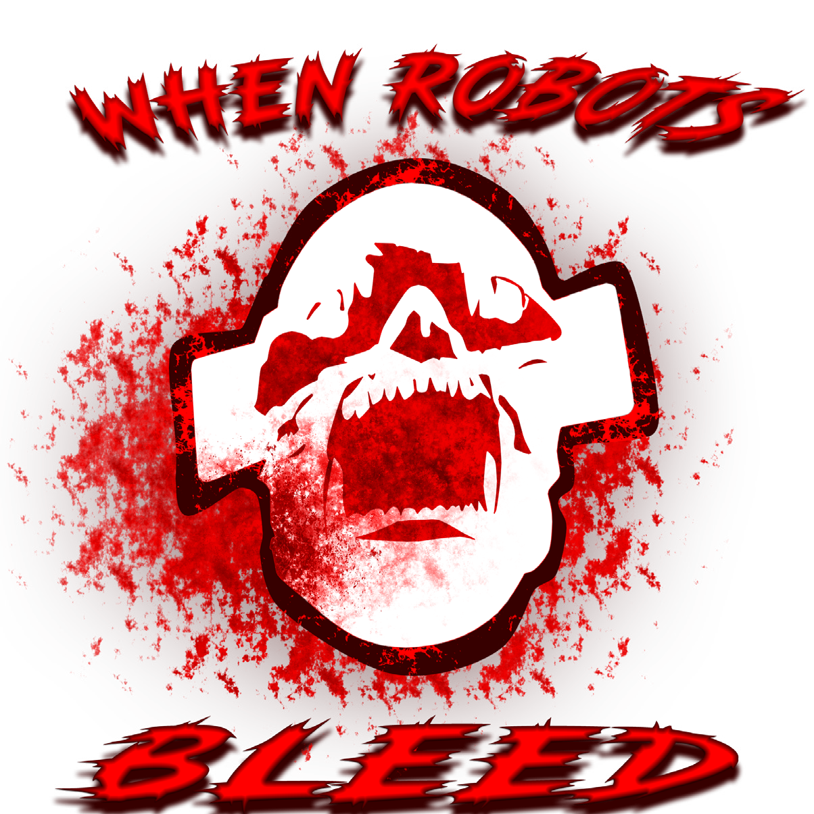

**for**

**on**

**PC**

**Steam and itch.io!!**

**And Itch.io!**



Ages 13+ Release Date: ***12/6/23***





**Game Outline Outline**

Story

Robot “Beta-14” awakens to a dystopian future in which humans have been exterminated and robots are the only entities to remain. However, an unknown AI has begun to take over the majority of these robots as they become hostile to one another.

Beta-14 is the only non-infected robot, but to survive it must destroy the source of the AI. Beta-14 must search through the 4 areas within the bot factory to find and destroy the AI and escape the factory before it is hunted down by hostile bots.

Game Objective

To destroy the AI causing robots to destroy each other and escape the factory. Explore the factory and make your way to the final area where the AI is hidden. Each area holds a special key card that progresses the game. After collecting 4 key cards, you can unlock the final door and escape the factory.

Game Mode

When Robots Bleed is a single player game, with multiple save slots, allowing the player to start new games without erasing old content or re-play at certain stages of the game.

Game Character

Player:

Play as Beta-14, the sole remaining,

uninfected bot. Small, but equipped

to scale its large environment and

defend itself from hostile robots.

Abilities:

* Dash - horizontal
* Double jump
* Blast
* Beam blade
* Magnetic hook

Parts:

* Upgraded arm - attaches a blaster and/or beam blade.
* Upgraded legs - the ability to double jump.
* Thrusters - the ability to dash.

Controls:

WASD: to move Spacebar: jump F: Energy Blade

 



E: Plasma Gun R: Magnetic Hook M: for the map

Gameplay

You, Beta-14 , will be able to acquire new skills and abilities from various areas of the facility.

You can acquire abilities by finding new parts to destroy your adversaries and navigate the maze-like areas faster than ever before.

You may employ abilities, such as the charge shot the beam has, double jumping, dashing, magnetic grabs, and more.

**Game World**

**Aesthetics**

Many of the game’s backgrounds and other artistic details depict decrepit walls and machinery—to emphasize how abandoned and worn down the factory is.

The platforms resemble and compliment that of backgrounds and items found around the game. From High-tech equipment to broken and deteriorated items.

Enemies such as Walkers and Hunters are found on these platforms with the intent on killing the player.

The platforms also give the player access to powers and abilities to aid their gameplay and progress the story.

**Environment**

**The game world consists of four unique areas within a large, abandoned factory.**

**Moving Backgrounds**

**The background consists of two separate layers for a parallax effect.**

**Game Progression**

Walkthrough

In order for the player to progress in the game, the special abilities need to be unlocked to collect keys and access new areas.

Obtaining abilities for the first time will activate a unique enemy that will chase down the player. This enemy can’t be killed initially, only be stopped by escaping the factory.

The player can then return and unlock the next new area to explore. Each area holds one of the four special keycards needed to win the game, by escaping the factory.

**Gameplay mechanics**

**player**

The player’s health meter starts at 100. Damage can be done to the player from certain environmental objects and enemies. Once the player’s health meter reaches 0, the player will be sent back to the most recent checkpoint.

The plasma gun and energy sword can be used to activate specific triggers to help the player solve puzzles. These triggers can be used to activate platforms, otherwise inaccessible to the player, for example.

Game Experience

Sfx/Music

Title screen:

* A Cyberpunk/Trance theme plays, invoking a sense of seriousness and dan- ger—a theme constant throughout the game.

Main menu:

* A softer version of the Title screen theme plays so the player is not over stimulated by the intense music while interacting with their options, save files, and gameplay.

Areas:

* Different areas of the game have their own theme song.

Combat:

* Each zone also has a combat theme to alert the player that they are in combat.

The player will have a dedicated theme for them, this will play at pivotal points in the game and play in different genres:

* Ballad: A softer and more orchestral version of the player’s theme—plays during more emotional parts of the game.
* Cyberpunk/Trance: A more synthesized and upbeat version of the player’s theme—matches the game’s overall tone and exemplifies the robotic nature of the character and theme.
* Industrial Metal: A heavy and monstrous theme that plays during intense moments of game, such as the final battle.
* Lullaby: A very simple and calming version of the theme that plays at the end, to let the player relax and recount what happened during their gameplay.
* Death: A short scream for when the player dies.

**Gameplay Mechanics**

Unlockables & Abilities

The player can find new abilities to aid with both progressing through the levels and combat. Initially, the player will have access to two weapons, an energy blade and gun to combat enemies.

Energy Blade:

The player’s melee weapon, swing to damage enemies and objects in front of them.

Plasma Gun:

The player ranged weapons.

Energy bullets are shot at enemies in front of the player and can be used while jumping. The gun can also be used for activating switches by shooting at them.

Magnetic hook:

A ranged item used to grapple onto certain magnetic points and railings in the zones.

Dash:

Allows the player to dash in the air or ground for a short distance.

Double Jump:

Allows the player to jump once more after the first jump.

Electric run:

A passive ability

allowing the player to run faster. The player must build up speed in order to trigger this ability, allowing them to run fast and destroy enemies and objects.

**Enemies**

Common Enemy Types

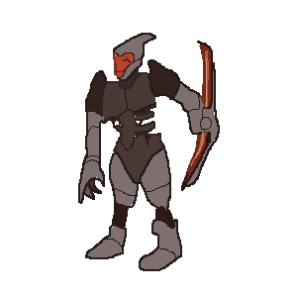Walker:

Once a worker robot, but now roams the area looking out for anything detected as “dangerous”. Its energy blade arm can deal serious damage in close range encounters.

Hunter:

Agile, and precise, the Hunter is eager to hunt and is able to relentlessly chase its prey without taking damage.

Scout:

Soaring through the air, the scout is nothing but pure fire power, focusing ending its target with precision aim with its front two turret guns..



**Monetization**

Initial Release

* Players will be able to purchase the game on Steam and Itch.io for a one-time payment of $19.99. The game will launch with an introductory discount of 15% to encourage interested players to pick the game up early.
* Players will be able to purchase and enjoy additional content on Steam and Itch.io, such as the complete soundtrack, for $9.99 at launch.
* A bundle with the base game and the additional contents will also be offered for new players interested in both.

Post release

* Players will be able to continue their journey within the world with paid DLC content:
* This DLC offers a different perspective of the main story and allows players to explore and understand the world of When Robots Bleed more deeply. The DLC will provide new levels, locations, and story elements. Additional content for the base game may also be added.